**Design Thinking Project Workbook**

**Don't find customers for your product but find products for your customers**

**1. Team**

**Team Name:**

**Automated Dietplan Chatbot for Gym Beginners**

**Team Members:**

1. T Varshith Swamy - 2320030196
2. B Sri Hari - 2320030300
3. T Sai Harsha - 2320030308

**2. Problem/Opportunity Domain**

**Domain of Interest: The innovative Recipe Recommendation and Meal Planning Chatbot will be applied in the health and wellness industry, specifically within the nutrition and meal planning sector. This chatbot can serve a diverse range of users, including health-conscious individuals, fitness enthusiasts, nutritionists, and busy professionals looking for convenient meal planning solutions. It can also find applications in the food and hospitality industry, where personalized meal recommendations are becoming increasingly important, and in dietary consulting services, where nutritionists and dietitians can use the chatbot to provide tailored meal suggestions to clients.**

**Description of the Domain: The Recipe Recommendation and Meal Planning Chatbot operates in the health and wellness industry, focusing on personalized meal planning based on dietary preferences like vegetarian, vegan, gluten-free, and low-carb. Key elements include efficiency, nutritional information, and user engagement through an intuitive interface. Challenges involve managing complex data, catering to diverse dietary needs, and ensuring scalability. However, there are significant opportunities in meeting growing market demand, integrating real-time recipe APIs, and expanding features like shopping list generation and nutrient tracking, making it ideal for partnerships with health and fitness services.**

**Why did you choose this domain?: The personal and strategic reasons for selecting the health and wellness domain for the Recipe Recommendation and Meal Planning Chatbot stem from a combination of passion for promoting healthy eating habits and recognizing the growing market potential in personalized nutrition solutions. Many people face challenges in finding recipes that align with their dietary preferences, leading to poor meal planning or unhealthy choices. This project addresses that problem by offering a convenient and personalized solution. The market is expanding as more individuals and organizations focus on wellness, creating opportunities to solve a relevant issue while contributing to a healthier lifestyle.**

**3. Problem/Opportunity Statement**

**Problem Statement: Create a recipe recommendation and meal planning chatbot that can suggest meals based on user dietary preferences and constraints.**

**Problem Description: The problem is to develop a chatbot that provides personalized recipe recommendations and meal planning based on users' dietary preferences and restrictions (e.g., vegetarian, vegan, gluten-free, low-carb). The system should enhance user convenience by simplifying meal selection while considering nutritional factors like calorie counts and ingredient lists.**

**Context (When does the problem occur): The problem occurs when users struggle to find meal options that align with their specific dietary preferences or restrictions, such as vegetarian, vegan, gluten-free, or low-carb diets. This challenge is amplified when users need to plan meals for multiple days, manage nutritional intake, or save time in selecting appropriate recipes. Busy individuals, those with health concerns, or those following strict diets often face difficulty in finding convenient, nutritious, and suitable meal options. The chatbot addresses this issue by providing tailored recipe recommendations and meal planning assistance, simplifying the process.**

**Alternatives (What does the customer do to fix the problem): The primary customers affected by this problem are health-conscious individuals, people with dietary restrictions (e.g., vegetarians, vegans, gluten-free), fitness enthusiasts, and those managing specific diets for medical reasons. Additionally, busy individuals seeking convenient meal planning and those aiming to maintain balanced nutrition are frequently impacted.**

**Customers (Who has the problem most often): Customers often feel frustrated and overwhelmed by the time and effort required to find suitable meals that meet their dietary preferences or restrictions. They may feel anxious about maintaining a balanced diet, unsure of nutritional content, or stressed about planning meals in advance, especially with busy schedules.**

**Emotional Impact (How does the customer feel): The measurable impact of the problem includes wasted time spent searching for appropriate recipes and planning meals manually, which can take hours each week. Additionally, users may face increased food costs due to inefficient meal planning or purchasing incorrect ingredients, and may struggle with managing calorie intake or dietary goals, affecting their health outcomes.**

**Quantifiable Impact (What is the measurable impact): To address the problem, customers often rely on manual recipe searches, use generic meal-planning apps, or follow diet-specific blogs and cookbooks. They may track meals using separate calorie counting apps or consult nutritionists for personalized meal plans, which can be time-consuming and less integrated.**

**Alternative Shortcomings (What are the disadvantages of the alternatives): The current alternatives have several shortcomings. Manual recipe searches can be time-consuming and may not always cater to specific dietary needs. Generic meal-planning apps lack personalization, while diet-specific blogs or cookbooks offer limited variety. Separate calorie tracking apps are often disconnected from meal planning, making it harder to manage nutrition holistically. Additionally, consulting nutritionists can be costly and not easily accessible for all users.**

**Any Video or Images to showcase the problem: The evidence in the form of video or image).**

**Provide link if available**

**3. Addressing SDGs**

**Relevant Sustainable Development Goals (SDGs):**

**SDG 3: Good Health and Well-being**

**The chatbot promotes healthy eating by providing personalized meal recommendations that align with dietary preferences, helping users maintain balanced diets and overall well-being.**

**SDG 12: Responsible Consumption and Production**

**By recommending healthy recipes and meal plans, the chatbot encourages mindful food consumption, potentially reducing food waste and promoting sustainable eating practices.**

**SDG 2: Zero Hunger**

**The chatbot can be adapted to provide nutritious meal recommendations for individuals in food-insecure regions, ensuring access to healthy and affordable food options.**

**How does your problem/opportunity address these SDGs?:**

SDG 3: Good Health and Well-being

By offering tailored meal plans based on dietary preferences and nutritional needs, the chatbot promotes healthier eating habits, which can help reduce diet-related health issues such as obesity, diabetes, and heart disease. Empowering individuals to make informed choices about their meals supports overall well-being and disease prevention.

SDG 12: Responsible Consumption and Production

The chatbot encourages responsible food consumption by providing users with recipes that match their dietary needs, potentially leading to reduced food waste. Efficient meal planning also helps users make more sustainable choices, such as opting for plant-based diets or utilizing available ingredients, thus promoting environmental sustainability.

SDG 2: Zero Hunger

With proper adaptation, the chatbot could provide meal recommendations that prioritize affordable, nutritious ingredients, helping to combat hunger and malnutrition in vulnerable communities. By promoting access to nutritious food, the chatbot can contribute to food security and healthier diets.

**4. Stakeholders**

Answer these below questions to understand the stakeholder related to your project

1. **Who are the key stakeholders involved in or affected by this project?**

The key stakeholders in this project include end users seeking personalized meal recommendations based on dietary preferences, health-conscious individuals tracking nutrition, and the developers responsible for building the chatbot. Nutritionists, recipe database providers, and potential partners like grocery services are also affected, especially for future expansion and integration.

1. **What roles do the stakeholders play in the success of the innovation?**

Stakeholders are vital to the innovation's success: end users provide feedback to refine the chatbot; health-conscious individuals offer insights on dietary needs; developers implement features and improvements; nutritionists validate recipe content; recipe database providers supply diverse options; and grocery stores facilitate easy ingredient purchasing, enhancing user convenience.

1. **What are the main interests and concerns of each stakeholder?**

Each stakeholder has distinct interests and concerns: *end users* seek personalized, convenient meal solutions that align with their dietary preferences while being easy to use; *health-conscious individuals* are focused on accurate nutritional information and tracking; *developers* aim for a robust, user-friendly system that integrates feedback; *nutritionists* are concerned about the accuracy and credibility of the nutritional data; *recipe database providers* are interested in ensuring their content is utilized effectively; and *grocery stores* are focused on maximizing customer convenience and potentially increasing sales through integrated shopping solutions.

1. **How much influence does each stakeholder have on the outcome of the project?**

Each stakeholder has distinct interests and concerns: *end users* seek personalized, convenient meal solutions that align with their dietary preferences while being easy to use; *health-conscious individuals* are focused on accurate nutritional information and tracking; *developers* aim for a robust, user-friendly system that integrates feedback; *nutritionists* are concerned about the accuracy and credibility of the nutritional data; *recipe database providers* are interested in ensuring their content is utilized effectively; and *grocery stores* are focused on maximizing customer convenience and potentially increasing sales through integrated shopping solutions.

1. **What is the level of engagement or support expected from each stakeholder?**

The level of engagement and support expected from each stakeholder varies. *End users* are anticipated to provide ongoing feedback and actively participate in usability testing, ensuring the chatbot meets their needs. *Health-conscious individuals* may engage through surveys or focus groups to share specific dietary concerns. *Developers* are expected to maintain high engagement throughout the project, collaborating closely to implement features and troubleshoot issues. *Nutritionists* are likely to offer their expertise during the development phase, ensuring accuracy in nutritional data. *Recipe database providers* should facilitate access to their content and may assist in curating recipes, while *grocery stores* are expected to support integration efforts and promote the chatbot to their customers, enhancing its visibility and usage.

1. **Are there any conflicts of interest between stakeholders? If so, how can they be addressed?**

Conflicts of interest may arise between stakeholders, particularly between *end users* wanting personalized options and *recipe database providers* who may prioritize popular recipes over niche preferences. Additionally, *grocery stores* might favor recipes that require readily available ingredients, which could limit dietary options for users with specific needs. To address these conflicts, open communication and collaboration among stakeholders are essential. Establishing a user feedback mechanism can ensure that end users’ preferences are prioritized, while periodic meetings can help align the goals of recipe providers and grocery stores with the needs of health-conscious individuals, fostering a more balanced approach to recipe selection and availability.

1. **How will you communicate and collaborate with stakeholders throughout the project?**

Communication and collaboration with stakeholders will be facilitated through a structured approach that includes regular updates, feedback sessions, and collaborative tools. We will establish dedicated channels, such as email lists and project management platforms, to share progress and gather input. Scheduled meetings—both virtual and in-person—will allow for discussions on design, features, and any concerns. Additionally, surveys and focus groups will engage end users and health-conscious individuals, ensuring their voices are heard. Continuous feedback loops will be created to incorporate stakeholder insights, fostering a collaborative environment that drives the project toward successful outcomes.

1. **What potential risks do stakeholders bring to the project, and how can these be mitigated?**

Stakeholders may introduce several potential risks to the project. *End users* may have unrealistic expectations, leading to dissatisfaction; this can be mitigated by clearly communicating the chatbot’s capabilities and limitations. *Health-conscious individuals* may require constant updates to dietary information, posing a risk of outdated content, which can be addressed through regular content reviews and collaborations with nutritionists. *Developers* might face technical challenges or delays, emphasizing the need for robust project management and contingency plans. *Recipe database providers* could change access terms or content quality, necessitating alternative sources and agreements to ensure continuity.

**5. Power Interest Matrix of Stakeholders**

**Power Interest Matrix: Provide a diagrammatic representation of Power Interest Matrix**

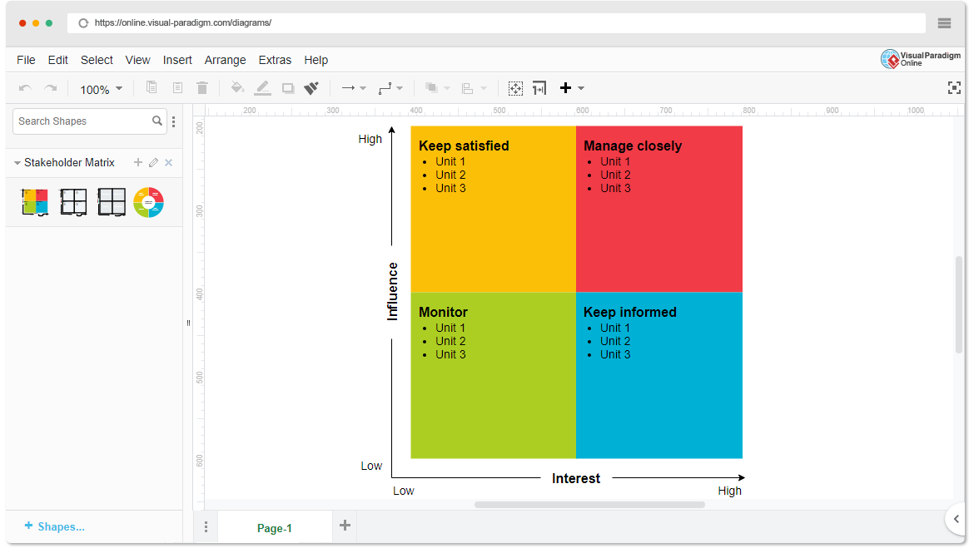

* High Power, High Interest: [Stakeholder Names]
* High Power, Low Interest: [Stakeholder Names]
* Low Power, High Interest: [Stakeholder Names]
* Low Power, Low Interest: [Stakeholder Names]

1. **Empathetic Interviews**

**Conduct Skilled interview with at least 30 citizens/Users by asking open ended questions (What, why/How etc) and list the insights as per the format below**

|  |  |  |
| --- | --- | --- |
| **I need to know**  **(thoughts, feelings, actions)** | **Questions I will ask**  **(open questions)** | **Insights I hope to gain** |
| Thoughts |  |  |
|  |  |  |
|  |  |  |
| Feelings |  |  |
|  |  |  |
|  |  |  |
| actions |  |  |
|  |  |  |
|  |  |  |

**SKILLED INTERVIEW REPORT**

**(Examples are given. Erase them and fill with your user information.)**

|  |  |  |
| --- | --- | --- |
| **User/Interviewee** | **Questions Asked** | **Insights gained (NOT THEIR ANSWERS)** |
| Abhishek Verma,  Student | Which party do you vote for? | Citizens are not very open about their political preferences |
| Srinivasan P., Parent | How do you feel about the plans for a new capital? | Some citizens are sad that the capital is being relocated from Hyderabad. |
|  |  |  |
|  |  |  |
|  |  |  |

**Key Insights Gained:**

* **Insight 1**
* **Insight 2**

**Empathy Map**

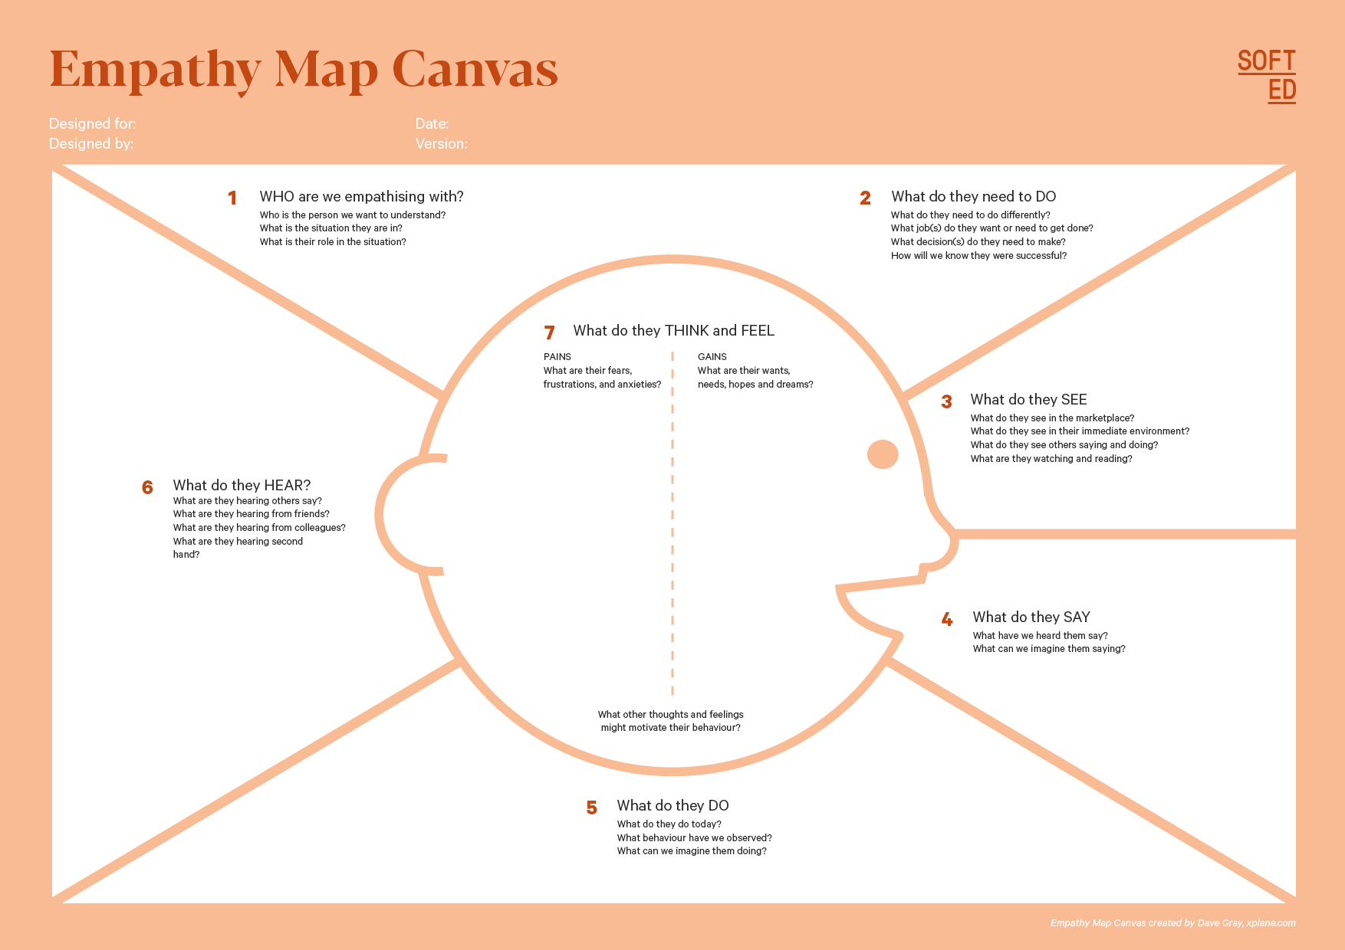

Your Answer:

Your Answer:

Who is your Customer Segment:

Idea/Innovation Title:

Designed By:

Date of Submission:

Your Answer:

Your Answer:

Your Answer:

Your Answer:

Your Answer:

Your Answer:

Your Answer:

1. **Empathy Map**
2. **Who is your Customer?**

**Description: This is where you specify the customer or user you are empathizing with. It could be a specific user persona or a general user segment.**

**Key points:**

* **Define the customer profile clearly (e.g., age, profession, interests).**
* **State their goals and needs related to the innovation or product.**
* **Context in which the user will interact with your solution.**

1. **Who are we empathizing with?**

**Description: This area helps you define who the user is, what their situation looks like, and what role they play. It emphasizes understanding the user’s perspective in depth.**

**Key points:**

* **Define the user's characteristics (e.g., personality, values, and responsibilities).**
* **State the user's goals and challenges in their environment.**
* **What is the user's broader situation (professionally or personally)?**

1. **What do they need to DO?**

**Description: This section identifies what actions or tasks the user needs to perform. It helps highlight the expectations and demands the user faces.**

**Key points:**

* **Clarify the tasks or actions the user needs to complete.**
* **What decisions do they need to make?**
* **How do they define success or failure in their tasks?**

1. **What do they SEE?**

**Description: This focuses on the visual stimuli or environment that the user interacts with. It's important to consider what users see in their immediate surroundings and in their larger world.**

**Key points:**

* **What do users see in their physical and digital environment?**
* **What trends or competitors do they notice?**
* **How do these visual elements influence their behavior?**

1. **What do they SAY?**

**Description: This section captures what the user might say in public, such as comments or feedback they give in conversations or on social media.**

**Key points:**

* **What might users express openly in conversation about their problems?**
* **How do they express their goals or frustrations?**
* **What are their words during customer interviews or feedback?**

1. **What do they DO?**

**Description: This section focuses on what the user does, the actual behaviors they exhibit, and actions they take in different situations.**

**Key points:**

* **What observable actions do users take?**
* **What habits or routines do they follow?**
* **What might users do to try and solve their problems?**

1. **What do they HEAR?**

**Description: This addresses what information the user receives from external sources, such as colleagues, media, or industry trends. It helps map the influences surrounding the user.**

**Key points:**

* **What are they hearing from peers, mentors, or the industry?**
* **What media or channels of information are they exposed to?**
* **Are there any strong influencers guiding their behavior?**

1. **What do they THINK and FEEL?**

**Description: This is one of the most insightful sections, addressing the internal emotions, concerns, and motivations of the user. It helps identify their deep-rooted feelings.**

**Key points:**

* **What are their fears, worries, and anxieties?**
* **What are their motivations and desires?**
* **How do their thoughts and feelings align with their actions?**

1. **Pains and Gains**

**Description: This section focuses on the user’s frustrations and their desired outcomes. It helps to frame the user’s challenges (pains) and the benefits they seek (gains).**

**Key points:**

* **What are the user’s main pain points?**
* **What would make their life easier or more fulfilling?**
* **What benefits do they hope to achieve from your product or solution?**

**8. Persona of Stakeholders**

**Stakeholder Name:**

**Demographics: Key characteristics of your target audience, such as age, gender, income, and location.**

**Goals: What the stakeholders or customers want to achieve in relation to the innovation.**

**Challenges: The obstacles or difficulties faced by stakeholders that the innovation aims to address.**

**Aspiration: The long-term desires or dreams of your target audience related to the innovation.**

**Needs: The essential requirements of your customers or stakeholders that must be met.**

**Pain Points: Specific problems or frustrations experienced by the target audience.**

**Storytelling: A narrative that highlights the journey of the stakeholder or customer, illustrating the problem and how the innovation can solve it.**

**Sample:**

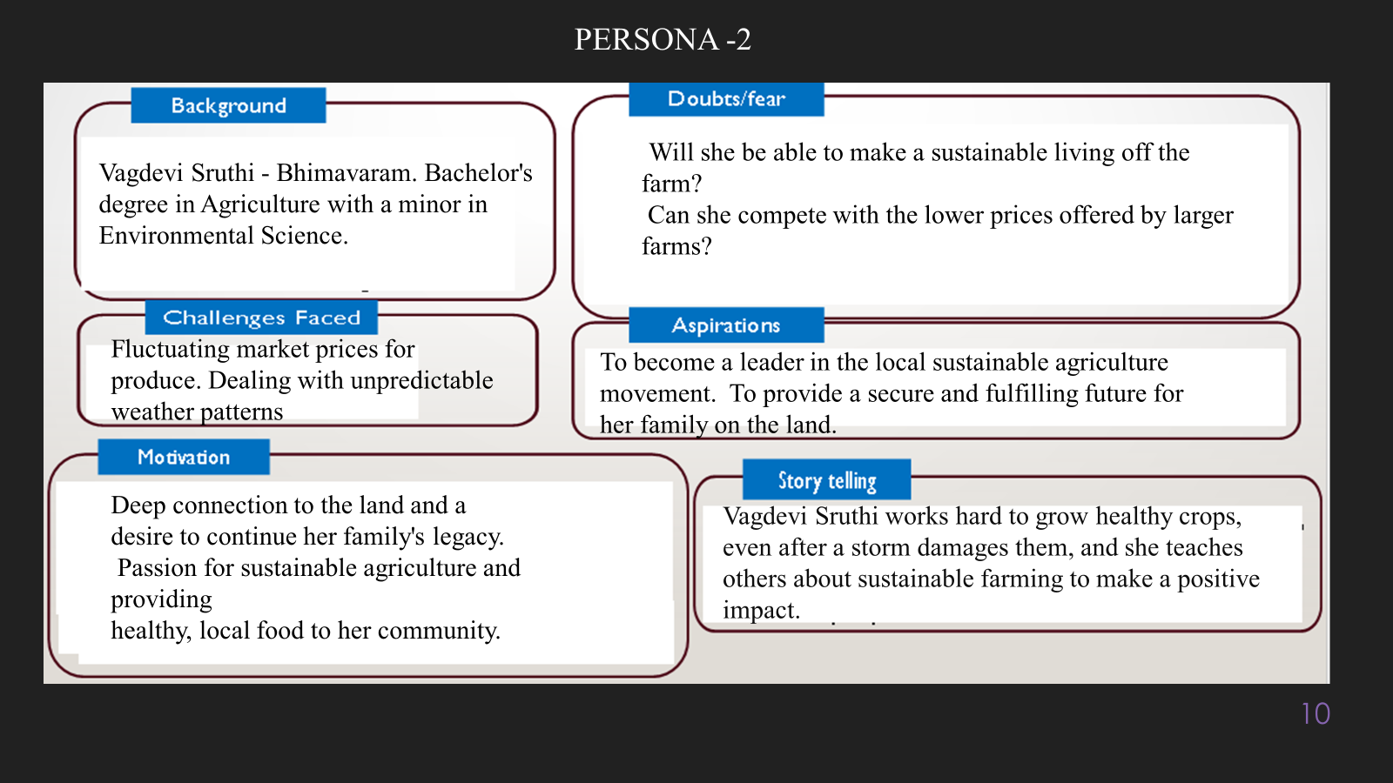

**10. Look for Common Themes, Behaviors, Needs, and Pain Points among the Users**

Analyse the data from your affinity diagram to uncover recurring patterns among your users, helping you better understand their expectations and challenges.

**Common Themes: Identify broad ideas or issues that repeatedly appear across different groups in your affinity diagram.**

**Common Behaviors: Observe how users consistently act or respond in relation to the problem or product throughout their journey.**

**Common Needs: Pinpoint essential requirements or desires that many users share, highlighting what they need for a better experience.**

**Common Pain Points: Look for frustrations or obstacles that frequently hinder the user experience, which your project can address.**

**12. Define Needs and Insights of Your Users**

**User Needs: Define the core requirements your users have in relation to the problem or product. These could be functional, emotional, or societal needs that your solution must address.**

**User Insights: Summarize the key understandings or observations you've uncovered about your users' behaviors, motivations, and pain points. These insights provide a deeper understanding of why users behave the way they do and what drives their decisions.**

**13. POV Statements**

**POV Statements:**

* [User] needs a way to [need] because [insight].

|  |  |  |  |
| --- | --- | --- | --- |
| PoV Statements  (At least ten) | Role-based or Situation-Based | Benefit, Way to Benefit,  Job TBD,  Need (more/less) | PoV Questions  (At least one per statement) |
| (Erase this example) When I drive to work, I want to avoid traffic jams so I don’t get in trouble with my boss for being late. | Situation | Way to Benefit | What can we design that will enable drivers to avoid traffic jams?  What can we design that will enable workers to avoid getting in trouble for being late to work? |
|  |  |  |  |
|  |  |  |  |
|  |  |  |  |
|  |  |  |  |

**14. Develop POV/How Might We (HMW) Questions to Transform Insights/Needs into Opportunities for Design**

Turn your user needs and insights into actionable opportunities by framing them as "How Might We" (HMW) questions. These questions will spark creative problem-solving and guide your innovation process.

1. **How Might We: Based on the needs and insights you've identified, create open-ended questions starting with "How might we...?" These questions should aim to solve user pain points, enhance the experience, or address specific needs.**

**Examples:**

* **User Need: "Users need a quicker way to access customer support."**
  + **HMW Question: "How might we create a more efficient and accessible customer support system?"**
* **Insight: "Users feel overwhelmed by too many options."**
  + **HMW Question: "How might we simplify decision-making for our users?"**

**Task:**

**Write 3-5 "How Might We" questions based on your analysis of user needs and insights. These questions should challenge you to think of innovative solutions that can address user problems in meaningful ways.**

**This task encourages participants to think creatively about solving user problems, transforming challenges into opportunities for innovation.**

|  |  |
| --- | --- |
| User Need/Insight | "How Might We" Question |
| [State the user need or insight clearly] | **How might we... [formulate an open-ended question to address the need or insight]?** |

**16. Crafting a Balanced and Actionable Design Challenge**

The Design Challenge Should Neither Be Too Narrow Nor Too Broad and It Should Be an Actionable Statement with a quantifiable goal. It should be a culmination of the POV questions developed.

**Design Challenge:** [Actionable Statement]

**17. Validating the Problem Statement with Stakeholders for Alignment**

Ensure your problem statement accurately represents the needs and concerns of your stakeholders and users. This involves gathering feedback from these groups to confirm that the problem is relevant and significant from their perspective. By validating early, you can refine the problem statement to better align with real-world challenges, ensuring your solution addresses the correct issues.

**Validation Plan:**

**Stakeholder/User Feedback (Min. 10 Stakeholders/Experts):**

|  |  |  |  |
| --- | --- | --- | --- |
| Stakeholder/User | Role | Feedback on Problem Statement | Suggestions for Improvement |
| [Name/Group] | **[Role/Title]** | **[Does the problem resonate with them? Why or why not?]** | **[Suggestions for refining the problem statement]** |
| [Name/Group] | **[Role/Title]** | **[Does the problem resonate with them? Why or why not?]** | **[Suggestions for refining the problem statement]** |

**18. Ideation**

**Ideation Process:**

|  |  |  |  |
| --- | --- | --- | --- |
| Idea Number | Proposed Solution | Key Features/Benefits | Challenges/Concerns |
| Idea 1 | **[Brief description of solution]** | **[What are the key benefits of this solution?]** | **[What challenges or concerns exist?]** |
| Idea 2 | **[Brief description of solution]** | **[What are the key benefits of this solution?]** | **[What challenges or concerns exist?]** |
| Idea 3 | **[Brief description of solution]** | **[What are the key benefits of this solution?]** | **[What challenges or concerns exist?]** |
| Idea 4 | **[Brief description of solution]** | **[What are the key benefits of this solution?]** | **[What challenges or concerns exist?]** |
| Idea 5 | **[Brief description of solution]** | **[What are the key benefits of this solution?]** | **[What challenges or concerns exist?]** |

**18. Idea Evaluation**

Evaluate the Idea based on 10/100/1000 grams

|  |  |  |  |  |
| --- | --- | --- | --- | --- |
| Idea | Impact (10/100/1000 grams) | Feasibility (10/100/1000 grams) | Alignment (10/100/1000 grams) | Total Weight |
| Idea 1 | **[Assign weight]** | **[Assign weight]** | **[Assign weight]** | **[Sum of weights]** |
| Idea 2 | **[Assign weight]** | **[Assign weight]** | **[Assign weight]** | **[Sum of weights]** |
| Idea 3 | **[Assign weight]** | **[Assign weight]** | **[Assign weight]** | **[Sum of weights]** |
| Idea 4 | **[Assign weight]** | **[Assign weight]** | **[Assign weight]** | **[Sum of weights]** |
| Idea 5 | **[Assign weight]** | **[Assign weight]** | **[Assign weight]** | **[Sum of weights]** |

**Example:**

|  |  |  |  |  |
| --- | --- | --- | --- | --- |
| Idea | Impact (10/100/1000 grams) | Feasibility (10/100/1000 grams) | Alignment (10/100/1000 grams) | Total Weight |
| Idea 1 | **1000** | **100** | **1000** | **2100** |
| Idea 2 | **100** | **1000** | **100** | **1200** |
| Idea 3 | **100** | **100** | **100** | **300** |

Further, use solution concept form to scrutinize the idea

**Solution Concept Form**

**1. Problem Statement:**

* **[State the validated problem your solution addresses.]**

**2. Target Audience:**

* **[Describe the main users or customers who will benefit from this solution.]**

**3. Solution Overview:**

* **[Provide a brief description of the solution concept.]**

**4. Key Features:**

| **Feature** | **Description** |
| --- | --- |
| **Feature 1** | **[Briefly describe the main feature of your solution]** |
| **Feature 2** | **[Briefly describe another key feature]** |
| **Feature 3** | **[Briefly describe a third key feature]** |

**5. Benefits:**

| **Benefit** | **Description** |
| --- | --- |
| **Benefit 1** | **[What value does this solution bring?]** |
| **Benefit 2** | **[How does this solution solve the problem?]** |
| **Benefit 3** | **[What makes this solution stand out?]** |

**6. Unique Value Proposition (UVP):**

* **[Summarize why this solution is unique and why it will appeal to your target audience.]**

**7. Key Metrics:**

| **Metric** | **Measurement** |
| --- | --- |
| **Metric 1** | **[What is the key metric to measure success?]** |
| **Metric 2** | **[What is another key metric for tracking progress?]** |

**8. Feasibility Assessment:**

* **[Provide a brief evaluation of how achievable or practical this solution is (consider resources, time, and technology).]**

**9. Next Steps:**

* **[Outline the next steps for further developing or prototyping this solution.]**